Name_____________________________________________ Date______________________ Birthdate______________________

Address_____________________________________________________________________________________________________

Residence and mailing | City |  | State | Zip Code
Home Phone (_______)________________ | Cell Phone (_______)_________________
E-mail address_____________________________@_________________________ |  |  | Male | Female
Occupation________________________________________ |  | Single___ Married___ Divorced___ Widowed___
Spouse’s Name_________________________ Children (name, age) _____________________________________________________

Who may we thank for referring you to our office? __________________________________________________________________

HEALTH HISTORY

Reason for seeking chiropractic care _______________________________________________________________________________

__________________________________________________________________________________________________________________
Are you under the care of any other doctor? (Medical, Chiropractic, or Other) | Yes | No

Previous Chiropractors you’ve seen in the past _______________________________________________________________________

If Yes, the conditions being treated for: _____________________________________________________________________________

List any current medications ______________________________________________________________________________________

List any current supplements______________________________________________________________________________________

List any past surgeries and dates __________________________________________________________________________________

List any past accidents and dates __________________________________________________________________________________

List any injuries you’ve had _______________________________________________________________________________________
Have you ever been under chiropractic maintenance care? Yes | No
POTENTIAL CAUSES OF SUBLUXATIONS

Please check (X) any stresses you have encountered since your last adjustment (or in your lifetime if you have never been adjusted).
PHYSICAL | MENTAL | CHEMICAL
Slip or fall | Work | Medications (OTC or prescription)
Sporting activity | Rush-hour traffic | Nicotine
Lifting | Taxes | Alcohol
Prolonged computer/TV time | Bills | Soda (regular or diet)
Sleeping in a weird position | Arguments | Fast food
Manual labor | Deadlines | Microwavable meals
Housework | Busy schedules | Energy drinks
Pregnancy | Homework | Sugar
Being born | Exams | Vaccines / Immunizations
(other)___________________ | (other)___________________ | (other)___________________

HEALTH INVENTORY

If you have experienced any of the following, please indicate by writing C (Current), P (Past), or C,P (Current and Past).

_______ Fatigue | _______ Neck pain / stiffness | _______ Loss of balance | _______ Lights bother eyes
_______ Sleeping problems | _______ Shoulder pain | _______ Earaches | _______ Cold sweats
_______ Frequent colds | _______ Mid back pain | _______ Ringing in ears | _______ Fever
_______ Asthma | _______ Low back pain | _______ Irritability | _______ Skin conditions
_______ Allergies | _______ Hip pain | _______ Depression | _______ Urinary problems
_______ Digestion Problems | _______ Joint pain | _______ Nervousness | _______ Mood swings
_______ Weakness | _______ Chest pain | _______ Tension | _______ Menstrual irregularity
_______ Dizziness | _______ Heart problems | _______ Ulcers | _______ Menstrual pain
_______ Headache | _______ Pins & needles in legs | _______ Pins & needles in arms | _______ Hot flashes
_______ Migraines | _______ Leg/foot pain | _______ Arm/hand pain | _______ Brain Fog
_______ Nausea | _______ Numbness in toes | _______ Numbness in fingers | _______ Difficulty focusing
_______ Fainting | _______ Cold feet | _______ Cold hands | _______ Unexplained weight loss/gain

Comments________________________________________________________________________________________________________

Disease/ | Symptoms/ | Asymptomatic/ | 100% Alive
Sickness | PAIN | NO PAIN | Healthy

Please put a X where you are currently. Please put an O where you would like to be.

FAMILY HISTORY

Cancer Heart Disease Arthritis Diabetes
Children
Siblings

Comments _____________________________
Mother

Father
______________________________________
______________________________________

Grandparents

The statements made on this form are accurate to the best of my recollection and I agree to allow this office to examine me for further evaluation.

____________________________________________________ ___________________________

Signature Date

FOR DOCTOR’S USE ONLY

________________________________________________________________________________________________________________________

________________________________________________________________________________________________________________________

________________________________________________________________________________________________________________________

________________________________________________________________________________________________________________________

Instructions: Please circle any possible symptoms you may be experiencing or have experienced in the past few months and any areas of your body that are of concern to you. Example: You have a heart condition and high blood pressure so you circle those under possible symptoms along with the heart under innervation.
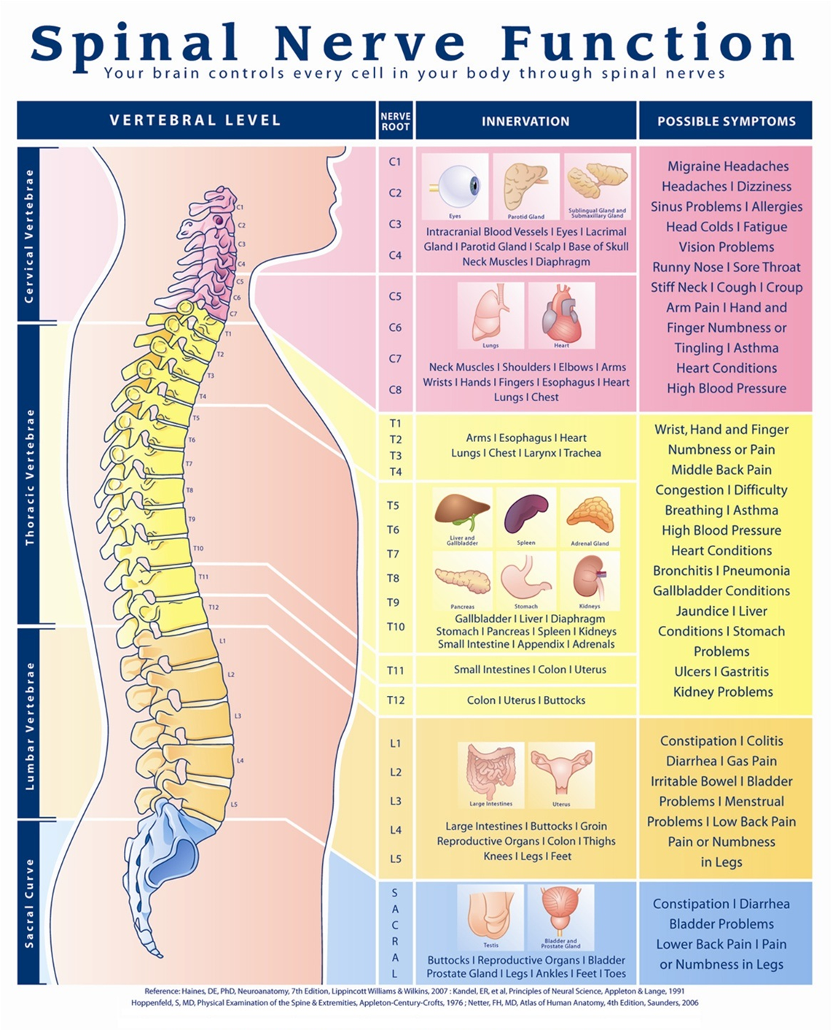

Informed Consent for Chiropractic Care

I hereby request and consent to the performance of chiropractic procedures, including various modes of physiotherapy, diagnostic x-rays, and any supportive therapies on me (or on the patient named below, for whom I am legally responsible) by the doctor of chiropractic indicated below and/or other licensed doctors of chiropractic and support staff who now or in the future treat me while employed by, working or associated with or serving as back-up for the doctor of chiropractic named below, including those working at the clinic or office listed below or any other office or clinic, whether signatories to this form or not.
I have had an opportunity to discuss with the doctor of chiropractic named below and/or with other office or clinic personnel the nature and purpose of chiropractic adjustments and procedures.
I understand and I am informed that, as is with all Healthcare treatments, results are not guaranteed and there is no promise to cure. I further understand and I am informed that, as is with all Healthcare treatments, in the practice of chiropractic there are some risks to treatment, including, but not limited to, muscle spasms for short periods of time, aggravating and/or temporary increase in symptoms, lack in improvement of symptoms, fractures, disc injuries, strokes, dislocations and sprains. I do not expect the doctor to be able to anticipate and explain all risks and complications, and I wish to rely on the doctor to exercise judgment during the course of the procedure which the doctor feels at the time, based upon the facts then known, is in my best interests.
I further understand that Chiropractic adjustments and supportive treatment is designed to reduce and/or correct subluxations allowing the body to return to improved health. It can also alleviate certain symptoms through a conservative approach with hopes to avoid more invasive procedures. However, like all other health modalities, results are not guaranteed and there is no promise to cure. Accordingly, I understand that all payment(s) for treatment(s) are final and no refunds will be issued. However, prorated fees for unused, prepaid treatments will be refunded if you wish to cancel the treatment. If you pay a discounted price and do not finish your agreement, your adjustments will be added up and you will be billed at the regular per adjustment price and whatever money is left will be refunded to you.
I further understand that there are treatment options available for my condition other than chiropractic procedures. These treatment options include, but not limited self-administered, over the counter analgesics and rest; medical care with prescription drugs such as anti-inflammatories, muscle relaxants and painkillers; physical therapy; steroid injections; bracing; and surgery. I understand and have been informed that I have the right to a second opinion and secure other opinions if I have concerns as to the nature of my symptoms and treatment options.
I have read, or have had read to me, the above consent. I have also had an opportunity to ask questions about its content, and by signing below I agree to the above-named procedures. I intend this consent to cover the entire course of treatment for my present condition and for any future condition(s) for which I seek treatment.
When a person seeks chiropractic health care and we accept him or her as a patient, it is essential for both to be working toward the same objective. It is important that each member understand both the objective and the method that will be used to attain this objective. This will prevent any confusion or disappointment. You have the right, as a patient, to be informed about the condition of your health and the recommended care and treatment to be provided so that you may make the decision whether or not to undergo chiropractic care after being advised of the known benefits, risks and alternatives.

All questions regarding the doctor’s objective pertaining to my care in this office have been answered to my complete satisfaction. The benefits, risks and alternatives of chiropractic care have been explained to me to my satisfaction. I have read and fully understand the above statements and therefore accept chiropractic care on this basis.

_____________________________ _____________________________ _____________________
Print Name Signature Date

PHILOSOPHICAL AGREEMENT
DEFINING THE TERMS OF ACCEPTANCE
Chiropractic is a science and art which concerns itself with the relationship between structure (primarily the spine) and function (primarily the nervous system) as that relationship may affect the restoration and preservation of health. Health is a state of optimal physical, mental and social well-being, not merely the absence of disease or infirmity.

One disturbance to the nervous system is called a vertebral subluxation. This occurs when one or more of the 24 vertebra in the spinal column become misaligned and/or fixated. This causes alteration of nerve function and interference to the nervous system. This may result in pain and dysfunction or may be entirely asymptomatic.

Subluxations are corrected and/or reduced by an adjustment. An adjustment is the specific application of forces to correct and/or reduce vertebral subluxation. Our chiropractic method of correction is by specific adjustments of the spine. Adjustments are usually done by hand but may be performed by handheld instruments.

If during the course of care we encounter non-chiropractic or unusual findings, we will advise you of those findings and recommend that you seek the services of another health care provider.

When a person seeks the services of a chiropractor it is absolutely essential to fully understand the objectives of that particular chiropractor.
It is not the goal or intention of Winters Family Chiropractic, PA to diagnose, treat, or attempt to cure any physical, mental, or emotional aliments, or to give advice about any aliments.
The only objective of this office is to help keep your body as free as possible from vertebral subluxations (bones of your spine that are out of place and putting pressure on your nerves). We do this because your body will simply work better when vertebral subluxations are limited in size and number.

_____________________________ _____________________________ _____________________

Print Name Signature Date

Consent to evaluate and adjust a minor child:

I, _________________________ being the parent or legal guardian of _______________________________ have read and fully understand the above Informed Consent and hereby grant permission for my child to receive chiropractic care.

Signature: ______________________________________________ Date: _________________

Acknowledgement of Receipt of Privacy Notice

Protecting the privacy of your personal health information is important to us. Disclosure of your protected health information without authorization is strictly limited to defined situations that include emergency care, quality assurance activities, public health, research, and law enforcement activities. Any other disclosures for the purposes of treatment, payment or practice operations will be made only after obtaining your consent.

-You may request restrictions on your disclosures.
-You may inspect and receive copies of your records within 30 days with a request.
-You may request to view changes to your records.
-In the future, we may contact you for appointment reminders, announcements and to inform you about our practice and its staff.

I understand that, under the Health Insurance Portability & Accountability Act of 1996 (HIPAA), I have certain rights to privacy regarding my protected health information. I understand that this information can and will be used to:

-Conduct, plan and direct my treatment and follow up with multiple healthcare providers who may be involved in that treatment directly or indirectly.
-Obtain payment from third party payers.
-Conduct normal healthcare operations such as quality assessments and physician’s certifications.

I have read and understand your Notice of Privacy Practices. A more complete description can be requested. I also understand that I can request, in writing, that you restrict how my personal information is used and or disclosed.

In compliance with federal law, a copy of the national Standards for Privacy of Individually Identifiable Health Information is available upon request. The Privacy Notice describes in detail how a member’s health information is used and shared with others.

All reasonable efforts will be made to protect the privacy of a member’s health information, whether it is maintained on paper or electronically, and regardless of how it is communicated, for example by e-mail or facsimile mail.

A copy of the Privacy Notice has been made available to me.

Name (print)____________________________________ | Date__________________
Signature______________________________________ | Date of Birth___________

When member is a minor, or is unable to give consent, the signature of a parent, guardian, or other representative is required.

Signature of Representative________________________ Date___________________

Print Name___________________________ Relationship to Member_______________

